# ROCO504 - Mine Detonating Sphere-bot Abstract

## Topic

For this project, our group has decided to work on our own topic rather than one of the provided ones. Our aim is to create a spherical robot that can detonate mines and be robust enough to function correctly after successfully activating a mine.

## Ideas

Original inspiration was gained by looking at videos of armadillos and how they protect themselves with a strong outer shell, as seen in this video <https://youtu.be/-x71UlnYVEU>. This led to an idea that replicated how the armadillo transformed into a ball shape, as shown in Figure 1.

Figure – original sketch of a robot that would be able to fold into a ball, like an armadillo

After this initial discussion we decided it would be more efficient to create a robot that is just always a sphere. The robot would be able to roll to the target, trigger the mine, then continuing rolling after the explosion. After doing some more research, on YouTube we found existing spherical robot designs and videos that show how a sphere can move: <https://www.youtube.com/watch?v=ar-YCHQK4ew> and <https://www.youtube.com/watch?v=5FHtcR78GA0> This then created the following ideas below, the steering of the sphere is still something we are thinking about as there are a few ideas we would like to test. Figure 2 shows our initial sketches.

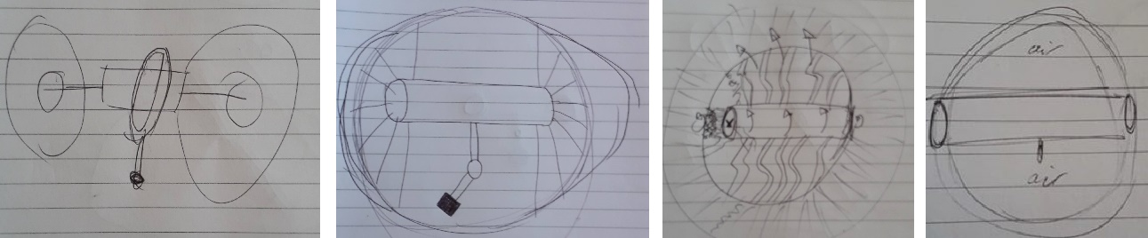

Figure – an idea for controlling movement with a pendulum, a potential design including steering, sphere and attachment, cylinder containing air

We would then like to add a soft outer shell to the spherical design so that the robot can deform on impacts so that the internals are better protected. This could also translate into choices for steering and driving the robot so that they are resistant to being dropped on either side after the robot has been blasted into the air. We will ensure as many parts as possible are 3D printed, as this will mean they will be cheap and easy to replace if it is damaged.

To achieve the soft outer shell of the robot it would have to be printed with NinjaFlex which is a softer 3D printing material compared to PLA. A few parts will have to be printed to see how tactile the NinjaFlex material is. We have also tested some 3D printed designs using Autodesk Fusion 360 to see if this design would work. This included testing different supports for the deforming sphere out of both PLA and NinjaFlex. Testing parts to be printed are seen below in Figure 3.

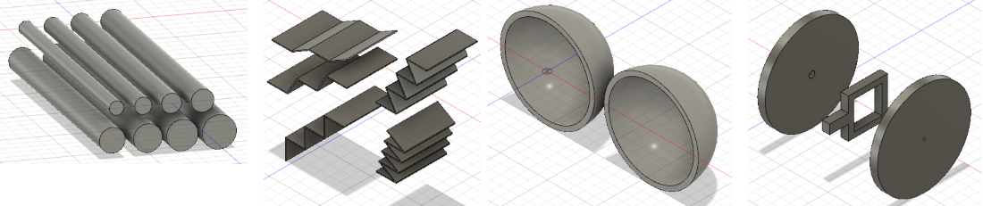

Figure – NinjaFlex cylinders, PLA concertina effect, a NinjaFlex sphere and a provisional design for movement of the sphere

Out of the 8 topics taught in this module we will be aiming to follow these 5 in this project: CAD; CAM; FEA; tensile/hardness testing; soft mechanisms and materials.